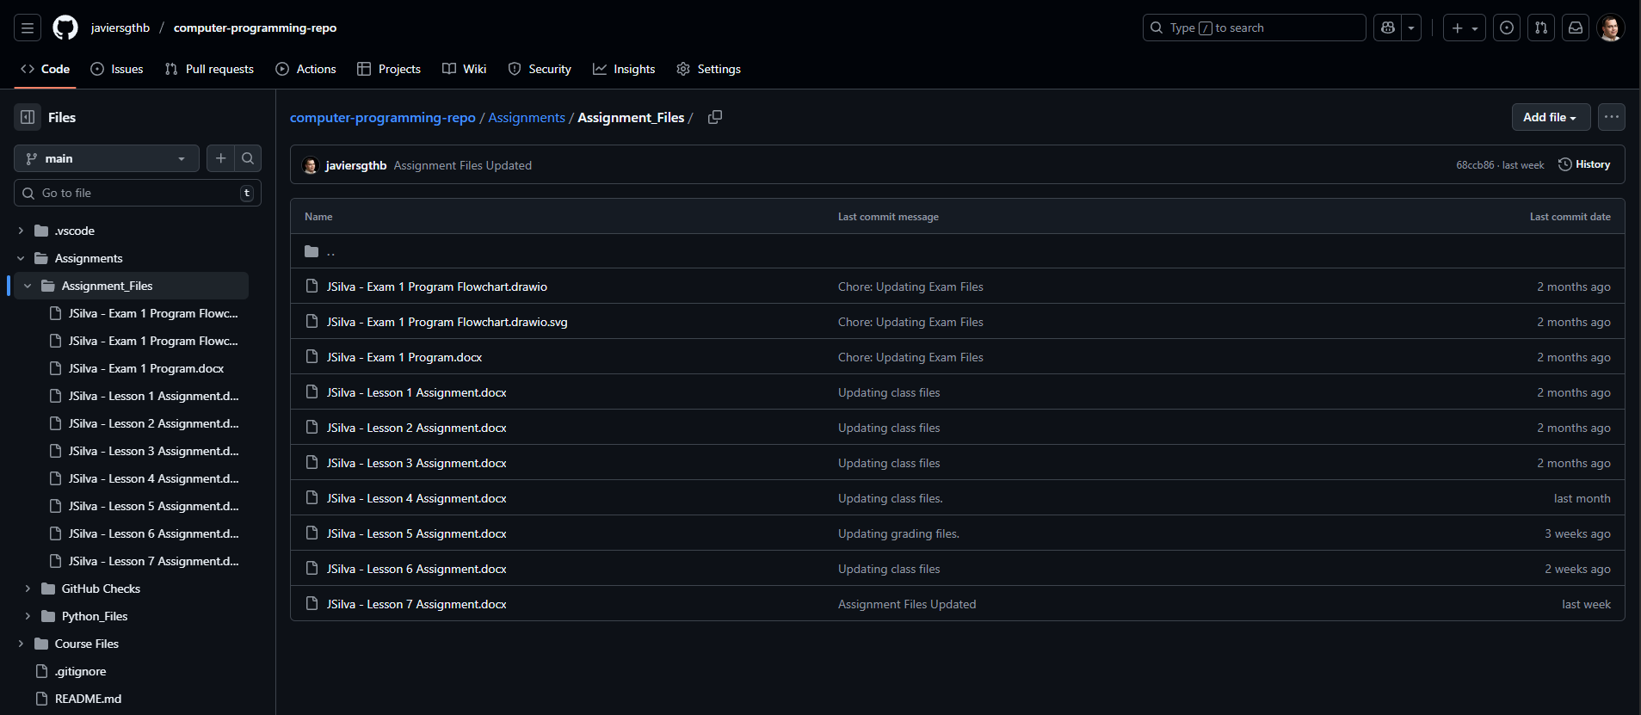
https://github.com/javiersgthb/computer-programming-repo/tree/main/Assignments/Assignment_Files

